**Front of the Card:**

* **Subject:** A king, not necessarily Vegeta, but a man with a great source of energy.
* **Pose:** Seated on a throne, relaxed and composed posture conveying humility and calmness.
* **Attire:** Ornate royal attire, possibly with subtle Saiyan-inspired details.
* **Transformation Element:** A moment of subtle transformation, such as hair slightly spiking or a faint golden energy beginning to surround him.
* **Expression:** Quiet confidence.
* **Eyes:** Golden glow hinting at immense power and a fierce spirit (like Vegeta's Super Saiyan glare).
* **Overall Impression:** Regal calm with an intense gaze, hinting at power beneath the surface.

**Back of the Card:**

* Simple yet elegant background.
* Subtle texture of golden energy, hinting at the king's power without being overwhelming.

Front of the Card:

Subject:

A king, not necessarily Vegeta, but a man with a great source of energy.

Pose:

Seated on a throne, relaxed and composed posture conveying humility and

calmness.

Attire:

Ornate royal attire, possibly with subtle Saiyan-inspired details.

Transformation

Element: A moment of subtle transformation, such as faint golden energy beginning to surround him.

Expression:

Quiet confidence.

Eyes:

Golden glow hinting at immense power and a fierce spirit (like Vegeta's

Super Saiyan glare).

Overall

Impression: Regal calm with an intense gaze, hinting at power beneath

the surface.

Please build an image

social media



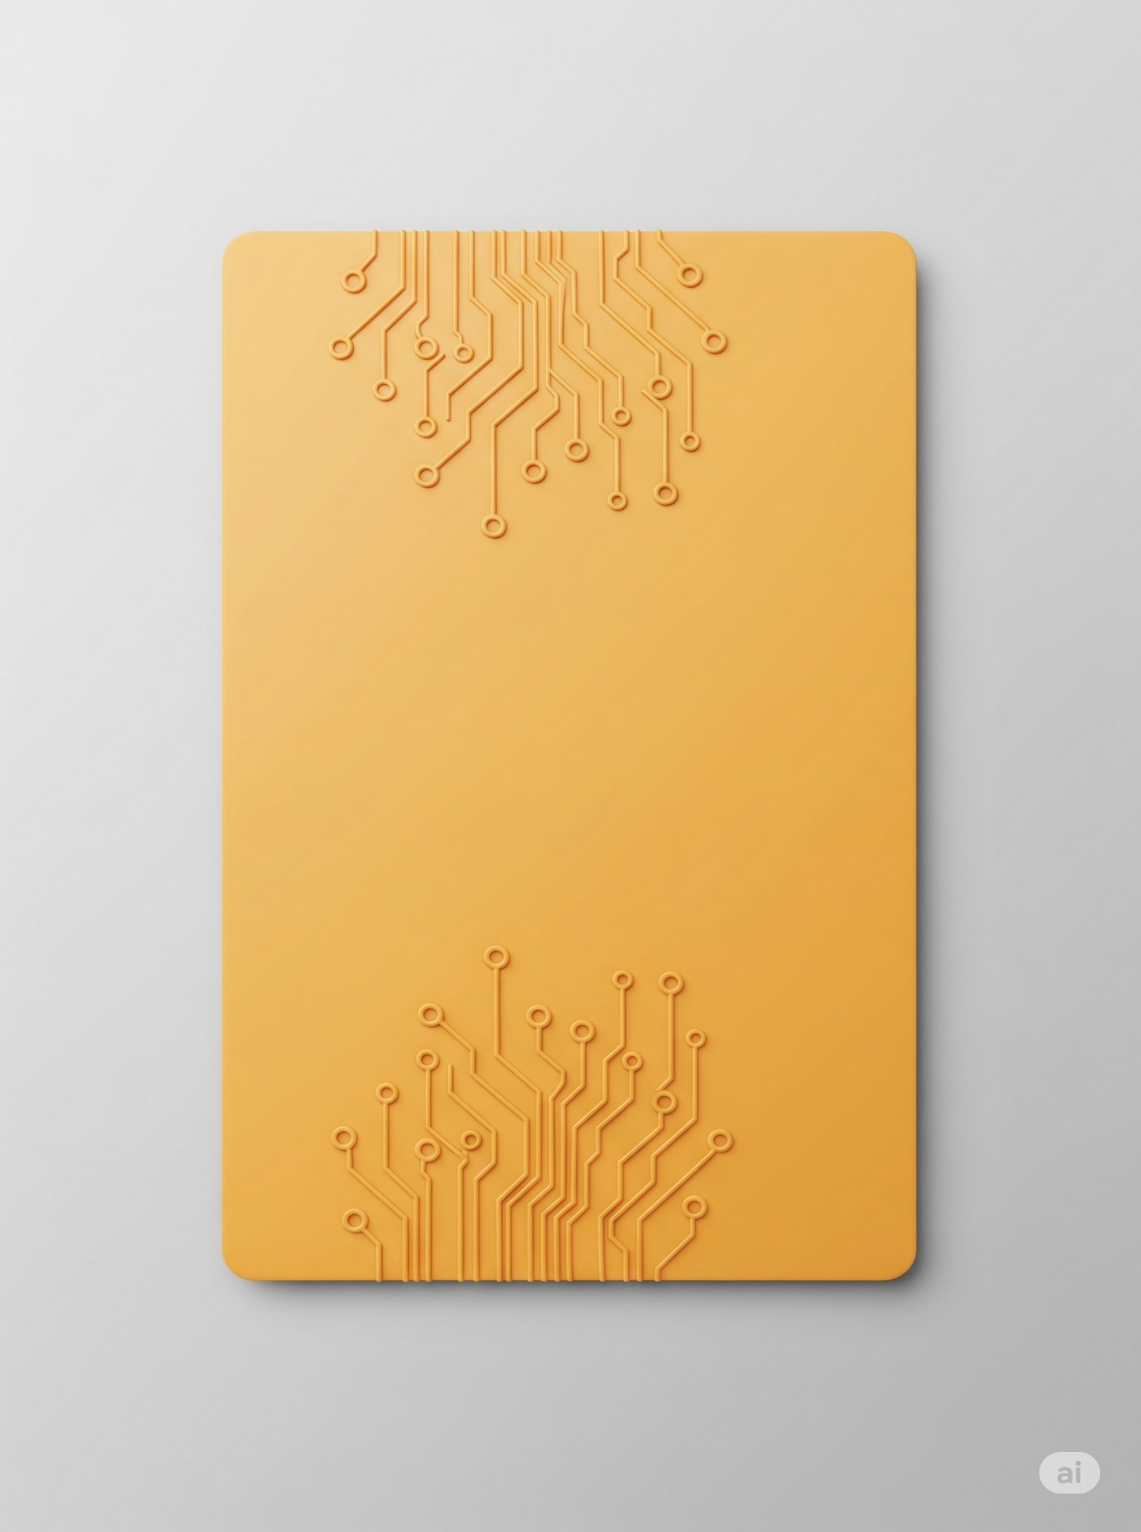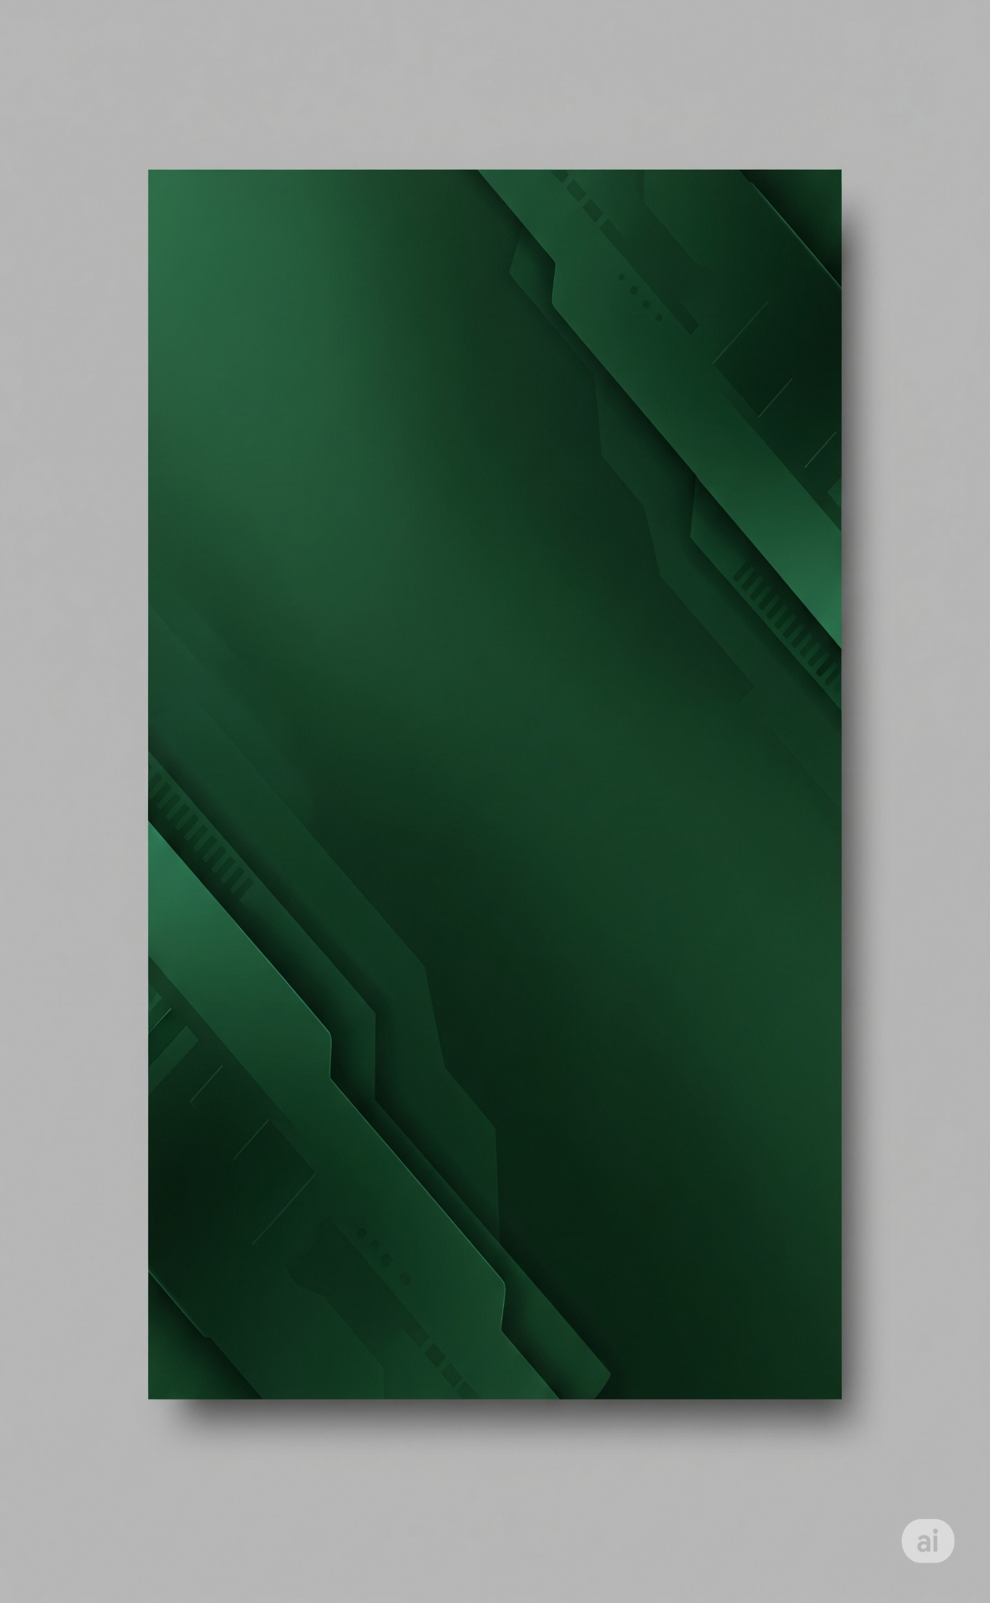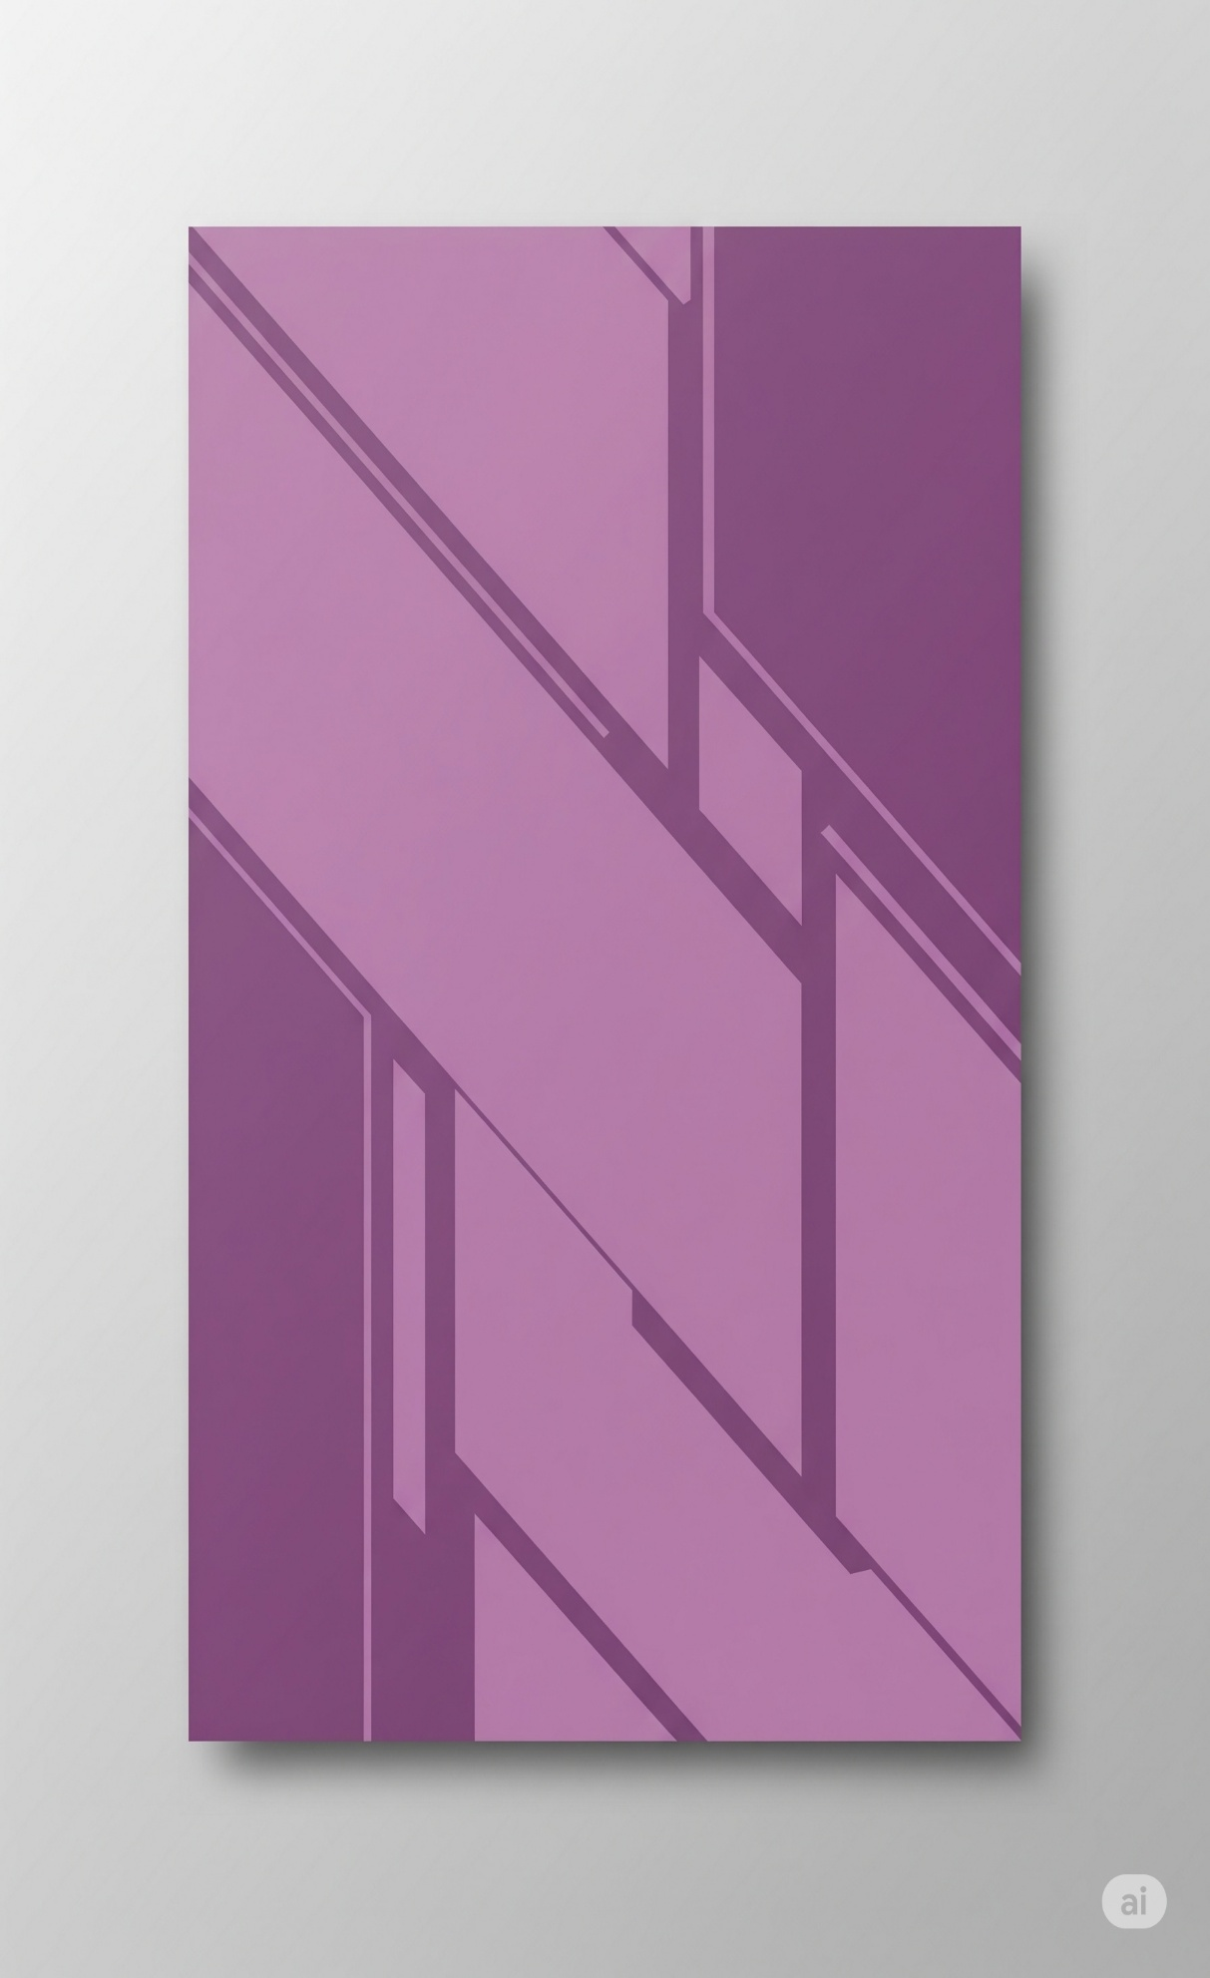

social media growth

engage redefined

connections link

community

platform

synergy

exchange networking

digital

modern

presence

interactions

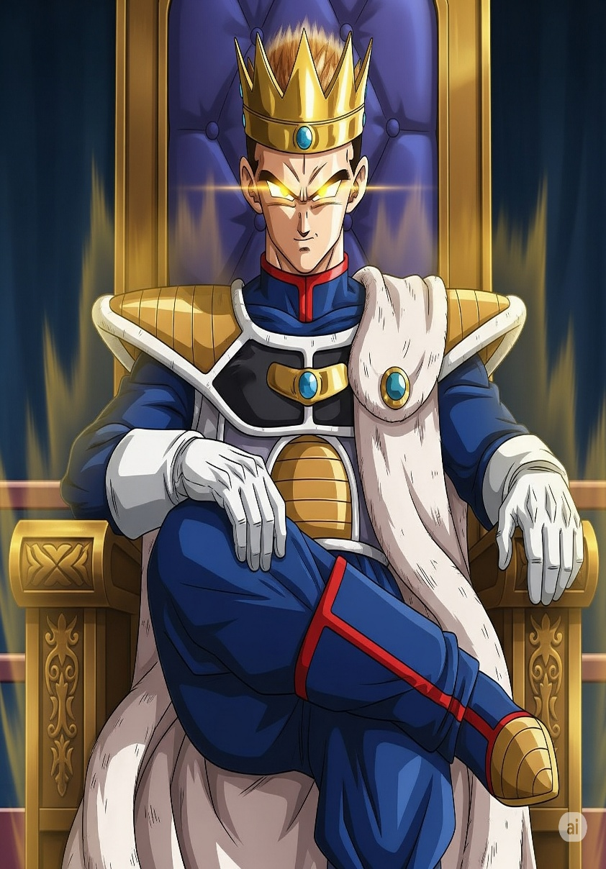

K **I** N **G**